**Country wise created reports**

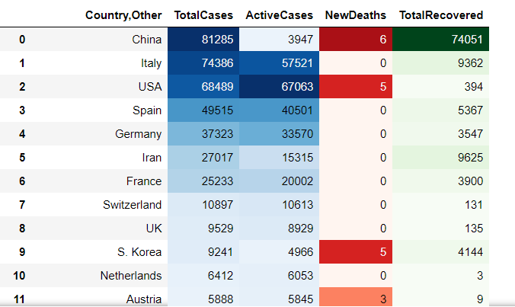

# Donut plot showing total Active, Recovered and Deaths

# 

# Pie plot showing Active cases w.r.t Countries

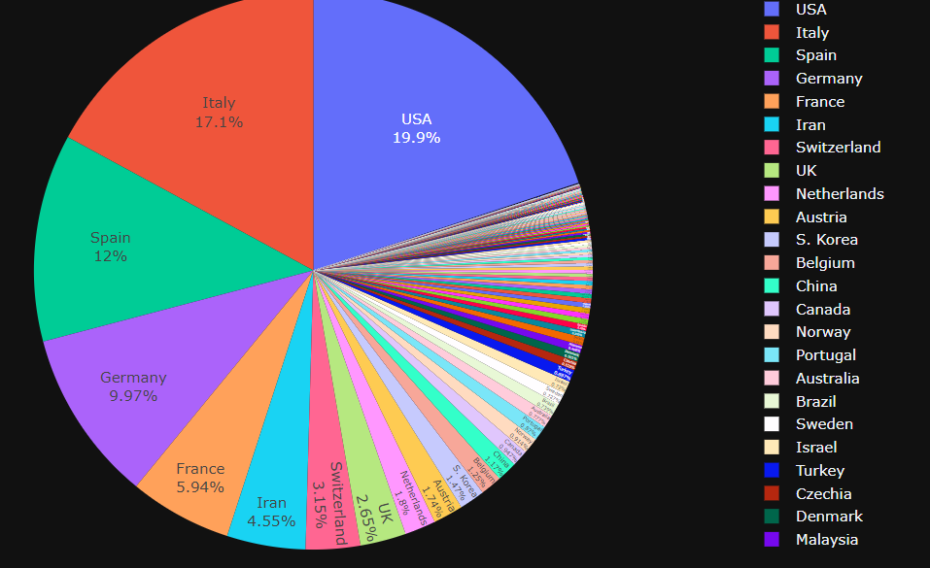

# Tree Map shows Country having Total cases

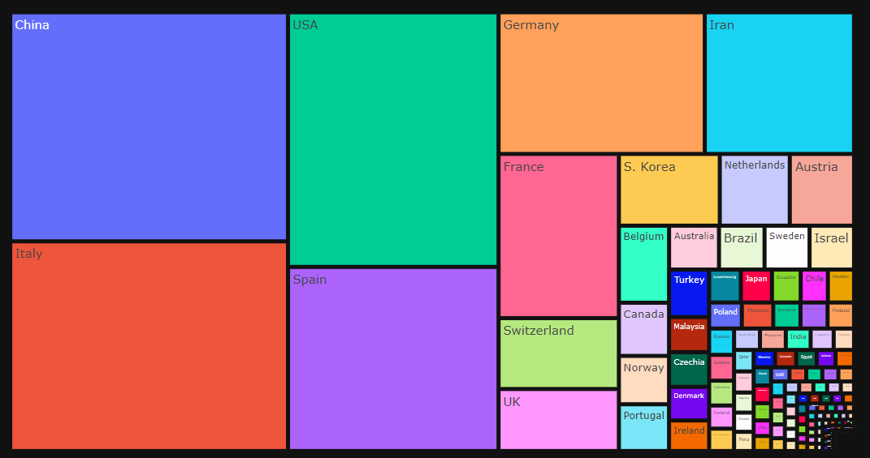

# Funnel area chart shows Country wise total deaths

# 

# Geographical globe impact on covid-19

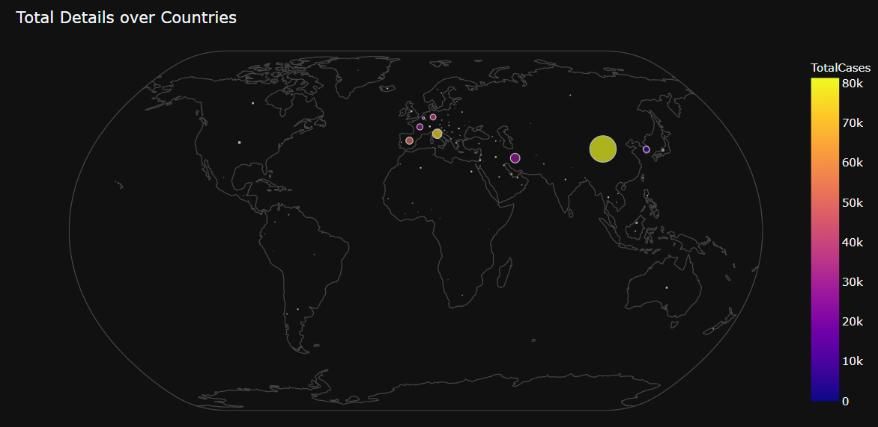

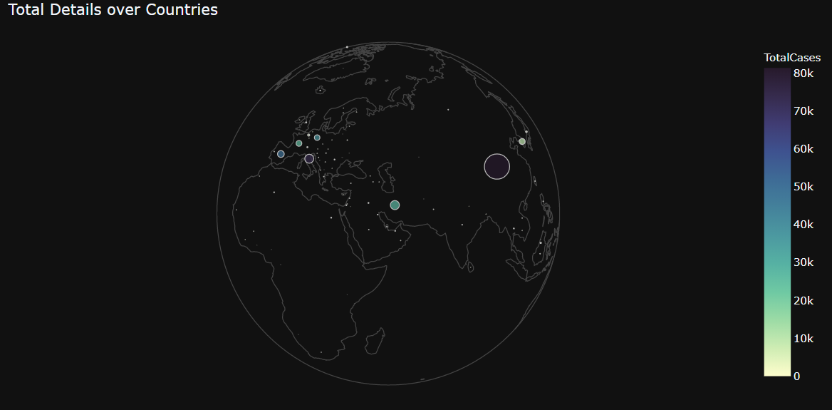

# World map showing confirmed cases of covid-19

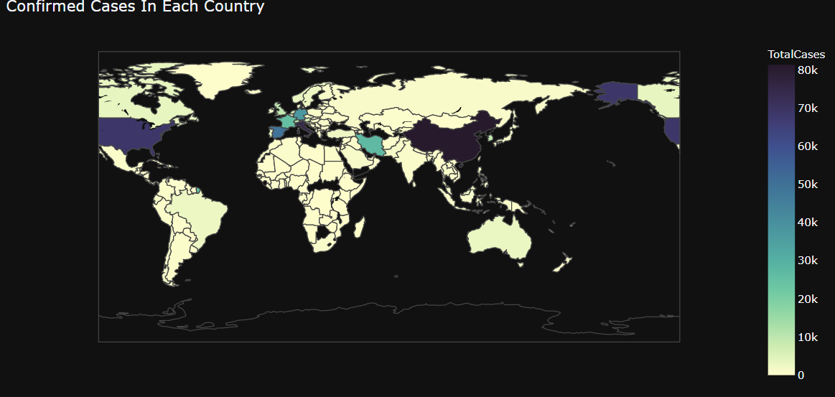

# World map showing Recovered cases of covid-19

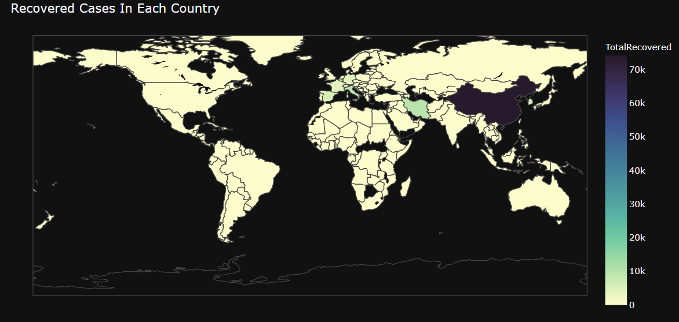

# World map showing Recovered cases of covid-19

